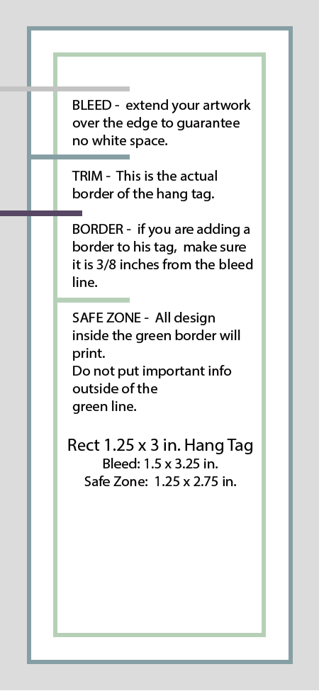 |  | Also, turn on gridlines for all hang tags by going to  Table Tools >  Layout >  View Gridlines.

